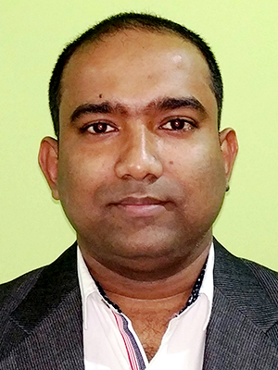
PROF (DR.) DIBYENDU SHIL
M Pharm, PhD
PRINCIPAL

Mata Gujri College of Pharmacy (A constituent unit of Mata Gujri University)

Experience
- Teaching and Research experience: 15 + Yrs.
- HOD, Department of Pharmacognosy: 3 years (2017-2020).
- Examination Coordinator: 14 + Yrs
Teaching Interest
- Pharmacognosy and Phytochemistry.
- Herbal drug technology & Pharmacological Screening
- Pharmaceutical Chemistry I
- Pharmaceutical Jurisprudence
- Pharmacy Practice
- Social Pharmacy
- Community Pharmacy
Research Interests
- Pharmacognosy and Phytochemistry.
- Quality control standardization of Medicinal Plants.
- Drug design, development in natural products.
- Phytopharmacological evaluations.
- Plant tissue culture.
Publications
- International Journal: 27
- National Journal: 3
- Conference : 17
- Books: 2
- The Indian Pharmaceutical Association (IPA) Life member
- Association of Pharmaceutical Teachers of India (APTI) life member
Contact information
- Email: drdibyendushil@gmail.com

Updated on July 2024

