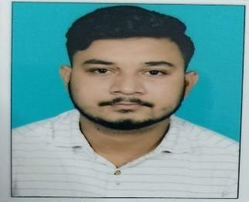

**Mr.Tanmay Jit Assistant Professor M.Pharm (Pharmaceutics)**

**Mata Gujri College of Pharmacy (Mata Gujri University) Teaching Experience- 1 Year**

Research Interests

* **Polymeric microsphere**
* **Mucoadhesive drug delivery system**
* **Nanoparticles**
* **Cocrystals Teaching Interest**
* **Pharmaceutics and Pharmaceutical technology**
* **Industrial Pharmacy**
* **Biopharmaceutics**
* **Physical pharmacy**
* **Dispensing Pharmacy**

Publications

* **International:04**
* **National:03**
* **Conference:03**
* **Book-1 Contact Information**
* **Email:**[**tanmayjit.mgcop@gmail.com**](mailto:tanmayjit.mgcop@gmail.com)

Updated on July 2024