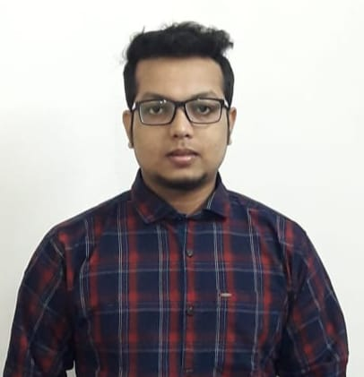

Mr. TANMAY MOHANTA

Assistant Professor

M. Pharm (Pharmaceutics)

**Mata Gujri College of Pharmacy, Kishanganj (Mata Gujri University)**

* Experience
* **3 Years 6 Months Teaching Experience**
* 6 Months Hospital Pharmacist
* 2 Month Pharmaceutical Industry
* **Academic Achievements**
* GPAT Qualified in 2018
* NIPER Qualified in 2018
* **Publications: 09** International:04,

National: 05

* **Conference:20**
* Research Interests
  + Dermatology
  + Microsphere
  + Nano structured lipid carrier
  + Wound Healing
  + Topical gel
* **Teaching Interest**
* Microbiology
* Biotechnology
* Pharmaceutics and Pharmaceutical Technology
* Biopharmaceutics and Pharmacokinetics
* Molecular Pharmacy
* Pharmaceutical Jurisprudence
* Cosmetics and Cosmeceuticals
* Dispensing Pharmacy
* Hospital Pharmacy
* Physical Pharmacy
* **Contact information**
  + **Email:** [**tanmay.mgcop@gmail.com**](mailto:tanmay.mgcop@gmail.com)

Updated on July 2024