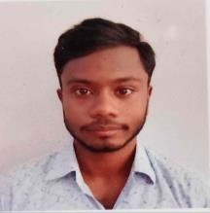

Mr. SANGLAP MALLICK

Assistant Professor

M. Pharm (Pharmaceutics)

**Mata Gujri College of Pharmacy (Mata Gujri University) Teaching Experience- 1 Year**

Research Interests

* **Mucoadhesive Nanoparticle**
* **Natural and Synthetic Polysaccharides**
* **Nasal route administration and Drug Delivery System Teaching Interest**
* **Pharmaceutics and Pharmaceutical technology**
* **Physical pharmacy**
* **Hospital and Clinical Pharmacy**
* **Pharmaceutical Jurisprudence**

Publications

* **International: 01**
* **Conference:03**
* **Book-1**

**Contact Details-**

* **Email:** [**sanglapmallick.mgcop@gmail.com**](mailto:sanglapmallick.mgcop@gmail.com)

Updated on July 2024