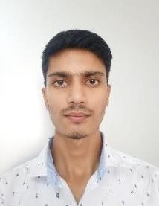

Mr. Sukanta Debnath

# M.Pharm (Pharmaceutical Chemistry)

**Mata Gujri Collage of Pharmacy (Mata Gujri University)**

**Teaching Experience:-**

10 Months

# Research Interest: -

* Computational Drug Discovery
* CADD
* LBDD

# Teaching Interest: -

* Computational Drug Discovery
* In-silico Drug Discovery
* Inorganic Chemistry
* Organic Chemistry
* Medicinal Chemistry
* Pharmaceutical Analysis

# Tanning and Expertise: -

* Maestro Schrodinger
* Chem Sketch (ACD Labs)
* Chem Draw (PerkinElmer)

Contact Information: - [sukanta.mgcop@gmail.com](mailto:sukanta.mgcop@gmail.com)

Updated on July 2024