**CURRICULUM VITAE**

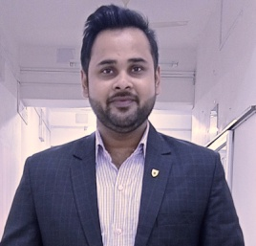

Mr. JAGJOT GAUTAM

Lecturer

**Mata Gujri College of Pharmacy, Kishanganj**

**(Mata Gujri University)**

# Experience: 6 Years

* + 1 Years as a Production Supervisor
  + 1 Year as a Pharmacist
  + 4 Year as a Lecturer(Till date)

# Research Interests:

* + Synthetic Chemistry
  + Phytochemistry
  + Phytochemical Analysis
  + Analytical Method Development
  + Chemistry of Natural Products
  + Extraction of Phytoconstituents

# Teaching Interests:

* + Pharmaceutical Inorganic Chemistry
  + Pharmaceutical Organic Chemistry
  + Medicinal Chemistry
  + Biochemistry
  + Analytical Chemistry
  + Hospital and Clinical Pharmacy
  + Human Anatomy and Physiology
  + Social Pharmacy

# Publication

* + International:01
  + Book Chapter:01
  + Conference:05

# ContactInformation

* + Email:[gautamjagjot@gmail.com](mailto:gautamjagjot@gmail.com)

Updated on July 2024