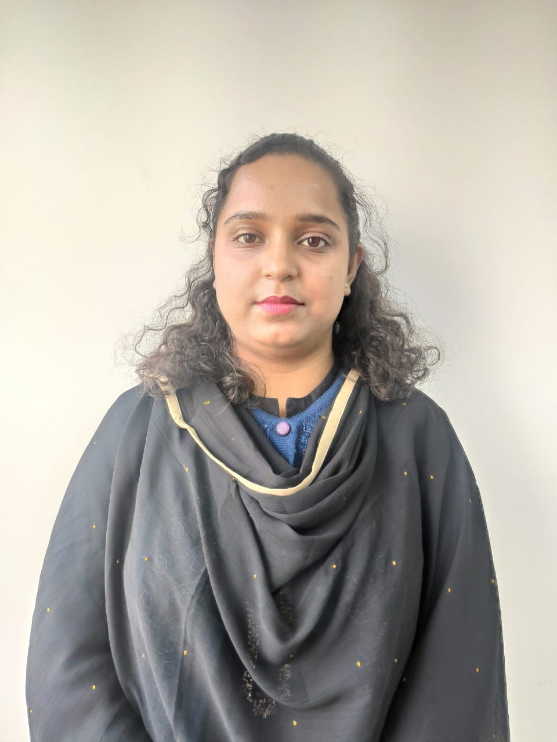

Ms. Chayanika Goswami

M. Pharm.

Assistant Professor

Mata Gujri College of Pharmacy

**Experience**

* Teaching experience: 1.8 years.
* Research experience: 2 months.

**Research Interest**

* Plant derived medicinal compounds
* Neuroscience
* Molecular mechanism of neurological disorder

**Teaching Interest**

* Pharmacology and Toxicology
* Human Anatomy and Physiology
* Pathophysiology

**Publications**

* Article: 3
* Book Chapter: 1
* Accepted Manuscript: 5

**Conference**

* International: 1
* National: 2

**Contact Information**

* Email: [chayanika.mgcop@gmail.com](mailto:chayanika.mgcop@gmail.com)

Updated on July 2024